VFD Motor Controller

Mackenzie Miller

Andrew Nguyen

Aidan Rader

Ryan Regan

**Concept of Operations**

REVISION – 1

28 April 2025

Concept of Operations

for

VFD Motor Controller

Team VFD Motor Controller

Approved by:

_____________________________

Project Leader Date

_____________________________

Prof. Lusher Date

_____________________________

T/A Date

**Change Record**

|  |  |  |  |  |
| --- | --- | --- | --- | --- |
| **Rev.** | **Date** | **Originator** | **Approvals** | **Description** |
| **0** | 9/15/2024 | VFD Motor Controller Team |  | Draft Release |
| **1** | 4/28/2025 | VFD Motor Controller Team |  | Final Report Update |

Table of Contents

Table of Contents III

List of Figures IV

1. Executive Summary 1

2. Introduction 2

2.1 Background 2

2.2 Overview 2

2.3 Referenced Documents and Standards 2

3. Operating Concept 4

3.1 Scope 4

3.2 Operational Description and Constraints 4

3.3 System Description 5

3.4 Modes of Operations 6

3.5 Users 6

3.6 Support 7

4. Scenario(s) 8

4.1 HVAC 8

4.2 Conveyor Belt 8

4.3 VFD Pump 8

5. Analysis 9

5.1 Summary of Proposed Improvements 9

5.2 Disadvantages and Limitations 9

5.3 Alternatives 9

5.4 Impact 9

List of Figures

Figure 1: VFD Motor Controller Block Diagram ....................................................................2

# Executive Summary

The sponsor for this project is in need of a VFD motor controller for an AC induction motor. The VFD will control the speed and torque of the AC motor. This project will help to increase energy efficiency by ensuring that the motor isn’t running at a higher speed than necessary. It also makes the system more reliable and sustainable by decreasing mechanical stress.

A Variable Frequency Drive (VFD) is a device that controls the speed of an electric motor by varying the frequency of the delivered voltage. VFDs are useful because they improve the energy efficiency, reliability, safety, stability, and controllability of a motor. The goal of this project is to make a VFD motor controller that will efficiently control the seed and torque of an electric motor.

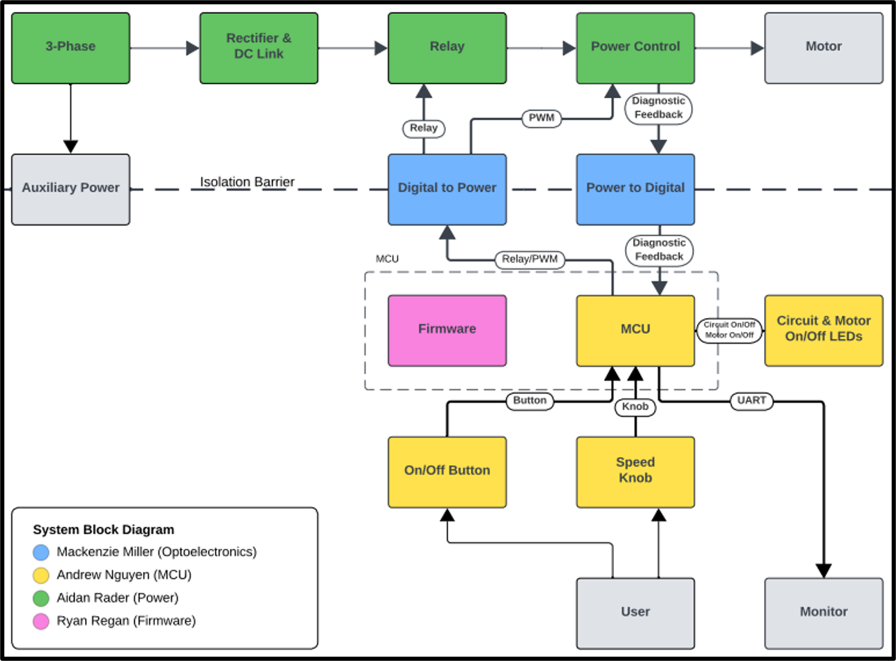

*Figure 1: VFD Motor Controller Block Diagram*

# Introduction

## 2.1 Background

VFD motor controllers have several beneficial functionalities that can improve the quality of a system. A VFD motor controller regulates the speed and torque of electric motors by controlling the frequency and voltage supplied. The speed is controlled by varying the frequency of the supply of electricity. It also allows for more efficient systems. By running at certain speeds, the VFD can reduce the power consumed, allowing for energy to be saved. It also reduces stress on the motor by allowing for soft starting and stopping. The VFD also has a functionality allowing it to shut off the motor if something is shorted, overheating, or overloaded. The VFD will replace a fixed speed motor in a mechanical system.

## 2.2 Overview

While fixed speed motor controllers are still useful in some applications, more often than not a VFD motor controller is a better alternative. It offers all the functionality of a fixed speed motor controller while also being able to vary the speed and torque of the motor if needed. In this project, our team will work to create a Variable Frequency Drive to control motor speed. In addition, we will consider several different factors such as user interface for the drive, and implementation of the drive in a closed and open loop. This upgrade will improve the energy efficiency, reliability, safety, stability, and controllability of the motor.

## 2.3 Referenced Documents and Standards

“The Advantages of Frequency Drive Operation in Submersible Pumps.” *Grundfos*, www.grundfos.com/us/learn/ecademy/all-courses/the-sp-submersible-pump/the-advantages-of-frequency-drive-operation-in-submersible-pumps. Accessed 15 Sept. 2024.

By, and Dosupply. “What Do VFDS DO in HVAC Systems?: Do Supply Tech Support.” *Do Supply Tech Support | Information and Troubleshooting on Allen-Bradley, Eaton, GE Fanuc, and More*, 11 Aug. 2022, [www.dosupply.com/tech/2022/08/11/what-do-vfds-do-in-hvac-systems/](http://www.dosupply.com/tech/2022/08/11/what-do-vfds-do-in-hvac-systems/).

Hoffman, Theresa. “What Are the Benefits of a Variable Frequency Drive?” Wolf

Automation,www.wolfautomation.com/blog/what-are-the-benefits-of-a-variable- frequency-drive/. Accessed 15 Sept. 2024.

“Variable Frequency Drive for Conveyor and Material Handling.” *Variable Frequency Drive for Conveyor and Material Handling-Darwin Motion*, darwinmotion.com/blogs/variable-frequency-drive-for-conveyor-and-material-handling#:~:text=The%20use%20of%20a%20Variable,belt%20speed%2C%20reducing%20energy%20consumption. Accessed 15 Sept. 2024.

IEEE 519-2014 Standard for Harmonics

# Operating Concept

## 3.1 Scope

The VFD motor controller is intended to control the speed and torque of an AC motor by varying the frequency and voltage supplied. This project will use three phase power as the input that will be converted to DC and then transmitted to a microcontroller via optoelectronics and used to power a motor. The microcontroller also will send signals to the DC link, again using optoelectronics, that contain the desired frequency specified by the user on the user interface. This VFD shall be implemented to increase efficiency and save energy.

## 3.2 Operational Description and Constraints

The VFD motor controller is designed to vary the frequency and voltage supplied to an AC motor to control its speed and torque. It converts a three-phase AC input into DC using a rectifier and transmitting the power using a microcontroller.

* Microcontroller Function
  + The microcontroller is responsible for generating pulse-width modulation (PWM) signals which are used to adjust the frequency and voltage supplied to the motor.
  + The user can set the desired motor speeds via the user interface or the code itself. The microcontroller then ensures that the motor is running according to its specifications.
* Optoelectronics
  + LED lights are used to communicate between the high-voltage power components and the low-voltage microcontroller. This ensures that the signals are safely transmitted.
* User Interface
  + The microcontroller will have a potentiometer that allows the user to change the frequency of the three-phase PWM signal that is being output to the motor.
  + While the PCB is plugged into a computer, opening the output terminal in MPLab will allow the user to view debug statements such as the potentiometer’s value, output duty cycles to phases A, B, and C, sine wave table step size, and desired output frequency of the PWM sine wave.
* Constraints:
  + Sustainability
    - Humidity, dust, and temperatures outside of the specified range can cause the VFD to malfunction.
  + Noise levels
    - The VFD is noise sensitive and is susceptible to external electrical noise, which could decrease the reliability of the system.
  + Power
    - The VFD requires stable three-phase AC power. Spikes or fluctuations could damage some of the system’s components.
  + Mechanical wear and maintenance
    - All parts of the VFD are subject to general mechanical wear and tear over time, especially if operated under high loads or in challenging environments.
  + Cost and installation
    - The VFD system can be expensive to produce, especially when considering large-scale applications. Consideration must be given to the specific needs of the project

## 3.3 System Description

The VFD motor controller is comprised of a DC link (includes a rectifier and DC bus), power controller, microcontroller, and optoelectronics. The DC link converts AC input into DC and minimizes the noise of the DC signal. The power controller controls the voltage. The microcontroller is used to produce PWM signals that will drive the motor. Optoelectronics allows for communication between the high voltage side and the low voltage microcontroller.

This is a four-person project, and the roles are be split into:

* Firmware:
  + Write code in C with MPLAB that programs the microcontroller so that it functions with the rest of the VFD system according to desired specifications.
  + Use a potentiometer to allow user to change the frequency of three-phase PWM signal.
  + Print debug and feedback signals to UART console to allow for even further debugging.
  + Test program on development board to ensure functionality then ensure proper integration with the project’s microcontroller.
* Optoelectronics
  + The first part of the optoelectronics portion includes two isolation circuits. One of those takes digital signals in and directly converts them to analog. The second, being more complicated, takes analog input, then, using an opto-isolator, the circuit converts the input to digital signals to be sent to the microcontroller. The analog side of the project works with very high voltage, while the digital side works with low voltage. Because of this, the two sides cannot be connected or the microcontroller will be overpowered and break, so the optoelectronics send signals and data across using light.
  + The second part of the sensors portion is a constant current and voltage measurement. This will be done using a current sensing resistor, which has a very small resistance, and a simple voltage divider circuit. These measurements will then be sent back to the firmware.
* Microcontroller:
  + The MCU board is supplied by taking in the 120VAC from the wall and using an AC/DC converter to step it down to 15VDC. The voltage is then stepped down once more using the LM2595s-3.3 buck converter to a usable 3.3V that the MCU can handle. It receives feedback through low-voltage analog signals that represent voltage and current. The MCU will then send out PWM signals to the H bridge and power control system which are used to adjust the output voltage and frequency supplied to the motor. The board will also supply the optoelectronics subsystem with a common GND and 3.3V, and the power subsystem with a common GND, 15V, and 3.3V.
* Power:
  + The rectifier takes in three-phase AC power and converts it into DC power. For each phase, there are parallel diodes acting as a one-way bridge for the current allowing it to flow in only one direction. To maintain the correct current polarity the diode opens and closes in sequence as the AC waveform alternates. The DC output is then filtered by capacitors within the DC link to provide a stable DC voltage for the microprocessor.
  + The power control will take the DC power and the PWM signals and output three modified sign waves at 120 degrees to the motor. It will also output three measurement signals that can be used as diagnostic feedback: voltage, current, temperature
  + The relay will take in a relay signal originating by the button press on the microcontroller and toggle the motor between on and off states.
  + Converters will be used as part of auxiliary power to generate the necessary voltage levels for the different integrated chips. The two converters on the power PCB with be a 3.3 VDC to isolated 5 VDC converter and a 15 VDC to isolated 15 VDC.

## 3.4 Modes of Operations

There are two primary modes of operation for the variable frequency drive:

On: The motor receives 10-60Hz PWM signals depending on the position of the potentiometer located on the microcontroller PCB. The frequency of the PWM signals changes the speed of the motor.

Off: The relay is tripped, and the motor is no longer receiving any power.

## 3.5 Users

The potential user for our VFD would be a plant operator or manager. The goal is to have it set up to ensure a seamless installation and programming process for use in a closed or open loop. It is assumed that a plant operator would know and understand what a VFD is and what it does. There will be simple controls that the user can change to make the VFD do what they want it to do such as a potentiometer for controlling the frequency of output signals, and a start/stop button.

## 3.6 Support

We plan to create a manual describing what the VFD does and how to use it. The VFD will support usage, programming, and debugging through MPLAB X IDE. It will allow the user to control the motor’s on/off function and its speed while showing the user several different variables including the measured motor speed from the tachometer.

# Scenario(s)

## 4.1 HVAC

VFDs can be extremely useful in a Heating, Ventilation, and Air Conditioning (HVAC) system. VFDs can act as speed controllers for HVAC motors because they actively adjust the speed rate of those motors based on the building load demands. Without a VFD, an HVAC system will run at full power regardless of whether the system requires full power at that time. By running only as powerful as needed, energy and money are saved. Additionally, a VFD allows an HVAC motor to slowly get up to the full speed which is called a “soft start”. This lessens wear and tear on these HVAC motors, which helps them to last longer and saves money. VFDs can help HVAC systems to control temperature and pressure, among other measurements in a building, they help to save energy and extend the life of HVAC motors.

## 4.2 Conveyor Belt

In conveyors for production lines, a VFD allows an operator to control the belt's speed to match the production line's needs. This ensures that the belt is not moving too slow to decrease efficiency or too fast to risk injuring employees and consume copious amounts of energy. Wear and tear is also decreased by being able to run the belt at the most appropriate speed as to not overwork the parts or run the belt for too long. The slow start that a VFD can offer helps to reduce wear and tear on the conveyor parts so they can gradually get up to speed. There is the ability to gradually slow down the belt when turning off, which also extends the life of equipment. The VFD increases energy efficiency and reduces maintenance which both save money.

## 4.3 VFD Pump

VFDs are sought after for submersible pumps for several applications. The main benefit of a VFD in a water pump is the ability to keep a certain parameter constant. VFDs are commonly used in construction sites to keep groundwater at a constant level to build. The VFD does this by adjusting the speed of the motor controlling the water pump. Additionally, VFDs are useful in maintaining constant pressure in a water tank. VFDs are crucial in the operation of water pumps across many different disciplines because their speed control allows for constant parameters in the specified system.

# Analysis

## 5.1 Summary of Proposed Improvements

Improvements:

* Extended life of parts: being able to vary frequency and torque help to reduce overloading equipment and, in turn, makes them last longer
* Increased efficiency: instead of a system having to run at a constant speed, a VFD allows the system to run only as fast as needed, which reduces energy consumption, and saves money
* Limits safety risks: having a system run at the proper speed and maintain a safe amount of torque helps decrease the risk of injury

## 5.2 Disadvantages and Limitations

Disadvantage:

* VFD can damage motor windings and bearings
* Can ruin insulation
* Creates harmonics (potentially interfering with communications and data processing)
* Can be very expensive
* Is prone to overheating if not in a properly ventilated area.
* Can create voltage spikes which could ruin the motor.

## 5.3 Alternatives

Alternatives to a VFD:

* Eddy Current Drive: induces a magnetic field that is adjustable to control the speed of a motor
* Soft Starters: Soft starters gradually increase the voltage to an AC motor during startup to reduce damage. They provide a more economical choice for applications where torque and speed control are only required during motor startup and stop.
* Cycloconverters: Cycloconverters convert the frequency of AC power from one frequency to another without having to convert to DC and back to AC. They are typically used in applications that require low speeds and high torque. This is a good alternative for when direct frequency conversion is more suitable than VFDs.

## 5.4 Impact

One environmental impact of a VFD is the ability to lower greenhouse gas emissions. By increasing the motor's energy efficiency through frequency adjustments to match load requirements, VFDs decrease the emissions released during the energy generation process.

A second environmental impact of a VFD is the degradation caused by mining the raw materials. While mining procures the rare metals needed for electronics, it also causes deforestation from the removal of forests, soil erosion from the disruption of the soil structure, and air pollution from the diesel emissions and dust particles generated by the machinery.

Another environmental impact of a VFD is the end-of-life disposal of electronic waste. Disposal of electronics can be challenging and, if done improperly, can contaminate soil and water with toxic metals. Alternatively, VFDs reduce this risk by reducing equipment wear, extending replacement intervals, and reducing disposal frequency.

A social impact of a VFD is the change in employment opportunities. The automation of the VFD reduces the need for operators who manually control the motor speed. Conversely, VFDs generate new roles including engineers who design the systems, miners who extract the raw materials, factory workers who assemble the components, and technicians who handle the maintenance.

Another social impact of a VFD is the safety risks. The VFD's automation of motor control within safe torque limits reduces the risk of accidents or injuries. However, if the VFD is improperly insulated or maintained, high voltages can pose a risk of electrical shock, and insulation breakdowns can pose a risk of short circuits and fire.

One ethical concern of a VFD is supply chain transparency. The raw materials for VFDs are often sourced from mines in countries with varying labor laws. In these mines, workers may face safety risks, including interacting with hazardous chemicals and dangerous machinery. Additionally, these mines should also avoid exploitative practices, including unfair compensation and unreasonable working hours.

A second ethical concern of a VFD is testing sufficiency. Before bringing a VFD to market, it should meet safety standards and demonstrate reliable operation. The testing process should include quality construction to prevent defects, comprehensive testing to identify defects, and clear documentation to resolve defects.